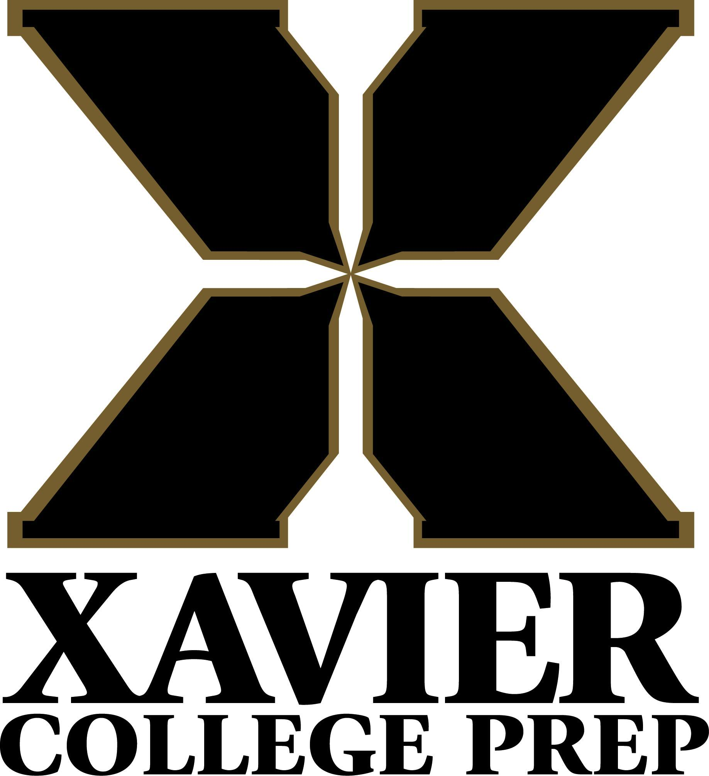

Xavier College Preparatory High School
34-200 Cook Street
Palm Desert, CA 92211

Social Studies Department
Advanced Placement United States History (APUSH)
School Year 2026-2027

Mr. Mark Hunter
mhunter@xavierprep.org
760-601-3900 ext. 6089

Office Hours:
7:45 am-8:45 am Monday, Tuesday, Thursday & Friday
Break & Lunch- By appointment After School- By appointment

SOCIAL STUDIES DEPARTMENT

All students at Xavier College Preparatory must complete seven semesters of Social Studies.
Xavier College Preparatory High School Social Studies Department is committed to helping students become creative and independent thinkers by guiding them in the understanding and analysis of important economic, geographic, legal, political, and social issues of our contemporary and historical world. Our mission is:
- To foster an understanding of the processes that are critical to solving complex problems, and to engage students in the regular practice of these problem-solving skills.
- To assist the student in seeing the world from different perspectives.
- To create students who can write clearly, critically, and persuasively;
- To guide our student population in their potential as citizens of a democratic nation and a contributing member of our local community.
- To strive for understanding of political, social, and economic issues.
- Make informed and reasoned decisions for the good of society.
- Participate as members of a culturally diverse society in an interdependent world.

As a result of participating in the Xavier College Preparatory High School Social Studies Department program, students will be able to independently …
- Participate actively and effectively as an informed citizen of a democracy;
- Critically appraise historical and contemporary claims/decisions/issues;
- Respect diverse cultures and honor equality and human dignity;
- Apply lessons of the past in order to anticipate and prepare for the future;
- Analyze the complex interactions between humans and the environment;
- Apply economic principles to solve complex problems.
COURSE DESCRIPTION

This course is a college-level survey of the history of the United States from pre-Columbian times to the modern era. The AP United States History course is designed to provide students with the analytic skills and factual knowledge necessary to deal critically with the problems and materials in U.S. history. The program prepares students for intermediate and advanced college courses by making demands upon them equivalent to those made by full-year introductory college courses. Students should learn to assess historical materials—their relevance to a given interpretive problem, reliability, and importance—and to weigh the evidence and interpretations presented in historical scholarship. An AP United States History course should thus develop the skills necessary to arrive at conclusions based on an informed judgment and to present reasons and evidence clearly and persuasively in essay format. Students will conclude the year with a National Exam from the College Board in May.

COURSE OBJECTIVES

Thematic Learning Objectives The thematic learning objectives describe, at a high level, the knowledge colleges expect students to develop in the AP U.S. History course in order to be qualified for credit and placement. In order to help students develop this knowledge, teachers will need to anchor their locally developed AP syllabi in historical content and skills. The learning objectives are grouped into seven themes typically included in college-level U.S. history courses:

- American and National Identity (NAT)
- Politics and Power (POL)
- Work, Exchange, and Technology (WXT)
- Culture and Society (CUL)
- Migration and Settlement (MIG)
- Geography and the Environment (GEO)
- America in the World (WOR)

These themes focus on major historical issues and changes, helping students connect the historical content they study to broad developments and processes that have emerged over centuries in what has become the United States. Each theme is presented with its description and a table that outlines the learning objectives for that theme on the College Board website page.

CATEGORIES/METHODS OF ASSESSMENT

Grades are calculated in a weighted manner using the following percentage distribution:

30% - Formative 50% - Summative 20% - Final
Assessments Assessments Examination
-Classwork -Tests
-Homework -Some Quizzes
-Reading Quizzes -Some Assignments
-Quizzes
-SLD Projects

Disclaimer: The teacher reserves the sole and complete right to modify the syllabus at any time. Know that minor syllabus modifications and adjustments are made throughout the semester, for a multitude of reasons. Know also that any changes are made for the good of the class and announced and promulgated as soon as possible.
Classwork & Homework: Students are expected to complete a major assignment in each chapter that will force them into the details of the text. All assignments must be handed in on time. Work handed in late will be penalized accordingly.
Late work: All assignments must be handed in on time. Work handed in late will be penalized accordingly.
- Turned in on time = Full possible credit.
- Turned in after prescribed due time but up to the end of school that day = ½ possible credit.
- End of the school day up to 6:00 pm = ¼ possible credit.
- After 6:00 pm = no credit

Quizzes/Reading Quizzes: Quizzes will be given on a weekly basis to make sure students are retaining the studied material. Most quizzes will be worth 25 to 35 points and may cover one or two sections. Reading Quizzes (RQ’s) will be given more often than the former, and are designed to evaluate the daily performance of the student’s comprehension in the reading. Most RQ’s are worth 10 to 20 points and cover just the required reading section from the night before. All Quizzes and Reading Quizzes will be a surprise, and will consist of either multiple choice questions, true and false statements, identifications/definitions, and/or short answers. A combination of these may occur once in a while. If excused absence for an RQ or a Q, you will be excused. There are no make-ups for excused missed RQ’s and/or Q’s.

SLD’s: Also known as Student-Led Discussions. Designed as a project to be completed in pairs, students are required to conduct an entire lesson on a section from the textbook. The lesson must include a PPT lecture format and notes, practical discussion questions, and a short assignment (the latter suggestion is optional)

Tests: Chapter Tests will usually be given after every second chapter. Each test will cover all the primary and secondary source readings, lectures, discussions, etc. since the previous test. Students who know they will be absent on the day of the exam must inform the instructor at least two days prior to arrange an alternate time to take the test. All pre-arranged and Make-Up tests are characteristically different in format and could possibly include added material that does not appear on the original Tests and/or Study Guides.

Semester/Quarter Finals: All Students are expected to take a Semester Final at the end of both semesters (quarters 2 and 4), and each Quarter Final (Quarters 1 and 3). The Final Examination at the end of the school year will be comprehensive. The purpose of the Final Examination is for students to exhibit depth of knowledge and sustained mastery of the subject material.

Class Participation: Each student is expected to be prepared and participate in any or all discussions either orally or in writing.

Other Classroom Activities: Classroom Activities consist of a variety of undertakings that are individual, group, or teacher-directed. All are designed to help students develop analytical skills that will facilitate analysis of primary source documents, secondary scholarship, and global historical content. Typical activities may include, but are not limited to the following:

- Analysis of writing: Students will be asked to design a rubric, develop a list of content expectations, and grade student sample essays and DBQs. Students will often compare released examples to their own writing samples.
- Court Case Analysis: Students will be asked to read and analyze a variety of court cases to understand the issues and decisions inherent in the cases. Emphasis will be on minority and majority opinions as well as the long-term significance of the cases.
- Debates (when time allows): Classroom debates are exercises designed to allow you to strengthen your skills in the areas of leadership, interpersonal influence, teambuilding, group problem solving, and oral presentation. Debate topics and position statements will be assigned by the instructor. Groups will be able to sign up on a first-come, first-served basis by specifying both the debate topic and the position desired (i.e., Pro or Con). All group members are expected to participate in the research, development, and presentation of your debate position. Each participating member will receive the same group grade.
- Discussions: Students read an article of historical scholarship on a given topic and come to the class prepared to discuss the issue. While the teacher’s role is one of facilitator, the students are graded on their participation and the quality of their answers. They must convince the teacher of their depth of knowledge in the source.
- Document Analysis: Students are asked to read and analyze primary source material. Accountability may be in the form of discussion, answering analytical questions, reporting to the class, or in the context of a more extensive assignment.
- In-Class Essays: Students will be asked to participate in timed writing. They will not be allowed to reference any material during the writing and will be graded on rubrics as determined by the Instructor, and promulgated in lessons.
- Lectures: Students will develop note-taking techniques required for success at the college level. Lectures will be power lectures that involve analytical questions in which student participation is required.
- Timed Writes: The largest part of the Advanced Placement Examination is the essay portion. Therefore, considerable time will be spent learning and practicing how to write a social studies/historical essay effectively. Students will usually be required to write essays starting in October. It is anticipated that all essays will be in class “timed writes.” Students who miss an in-class essay will be subject to the same make-up policy as those who miss an exam. Class essays will be similar to those given on the A.P. U.S. History exam.

STUDENT SUPPLIES AND MATERIALS

Students are expected to bring the following materials every day to class:
- Primary Text: Corbett, Scott P.; Janssen, Volker; Lund, John M.; Pfannestiel, Todd; Vickery, Paul. U.S. History, OpenStax. (Rice University: 2017)
- 3-Ring binder with several dividers (one for each quarter or semester, depending on size)
- Loose-leaf paper (College ruled only) for note-taking and spot assignments.
- Blue and/or Black pen for writing essays.
- Red/Green pen for grading assignments.
- iPads, laptops, tablets, Kindles, Chromebooks, or Surface Pros are allowed and required when we access the textbook or other materials in class.

Additional Resources:
- Documents in United States History, Upper Saddle River, New Jersey: Prentice Hall. 2024. Print.
- Foner, Eric, Voices of Freedom: A Documentary History Vol. 1 & 2. New York: W.W Norton Company: 2011. Print
- Zinn online: http://www.historyisaweapon.com/zinnapeopleshistory.html
- Review Text (Student purchased): Students are urged to purchase a 2023-2024 APUSH review text by the end of November. Please select from the following:
- AP US History Crash Course and Online (Advanced Placement (AP) Crash Course) 2024 Edition
  - Cracking the AP US History Exam: 2024 Edition
  - Barron’s AP United States History, 2024 Edition
  - The Princeton Review 2024 Edition
  - Kaplan AP US History 2024 Edition

CLASSROOM DEMEANOR, BEHAVIOR, AND OTHER

The class will run smoothly if the following behavior patterns are observed daily:

- Treat others with respect and courtesy.
- Follow directions maturely and responsibly.
- Bring the above required materials every day.
- All students will stand when an adult enters the room.
- Be in dress code (I will do a brief check every day, particularly the first period of the day
- Food or drink is not allowed in class without prior approval from the instructor.
- Bring your own tissue for nose and mouth issues; you will not be allowed to leave class to “use or get some tissue.”
- Electronic devices (iPads, laptops, tablets, Kindles, Chromebooks, or Surface Pros) are only used for academic purposes. I will inform you when you will be allowed to use the device in class. Otherwise, your device will be powered off and put away during the instructional period. Cell Phones are not allowed to be heard, seen, or used.
- All students will raise their hands when they wish to speak.
- Students are expected to participate and contribute in classroom discussions and note-taking. Students will not be working on other subjects while in class.
- We will be doing a lot of discussing in class. Therefore, your opinion might be different from a classmate's. Name-calling in class, including racial, ethnic, or sexual slurs, even if you think it is funny, will not be tolerated. Be critical of ideas, not people!
- Cheating in any form is not tolerated! You WILL exercise academic integrity. If you fail in this endeavor, you will be disciplined accordingly, the Dean of Students will be notified, and you will not receive any credit for the assignment, test, essay, etc.
- If a student needs to see me for any reason, please do so before school, at break, at lunch or after school. DO NOT come to me in the middle of the passing period, right before the start or end of a class.
- Do not abuse the privilege of using the restroom. Students will not be allowed to go during class unless it is an extreme emergency. Use the lavatory before you come to class. Coming into class and asking to use the restroom before class begins will not excuse you from being tardy.
- When in doubt about any behavior, consult Luke 6:31.

- Daily Lesson Topics and Homework Assignments: posted in two places in the classroom and on Canvas at the start of each quarter. Reminders at the start of each week will be posted on the front board.
- Student Grades: continuously available online on Canvas.

- Use of Technology: Electronic devices (iPads, laptops, tablets, Kindles, Chromebooks, or Surface Pros) are only used for academic purposes. CELL PHONES are not allowed to be heard, seen, or used while in class. If it is seen, it will be confiscated and given to the Dean of Students.

Note: Procedures and expectations are subject to change and modification at any time and at the discretion of the instructor.
All written assignments that will be turned in should have the following heading and format. Failure to do so will result in an increasing loss of points throughout the school year.

Headings and Format for all written assignments
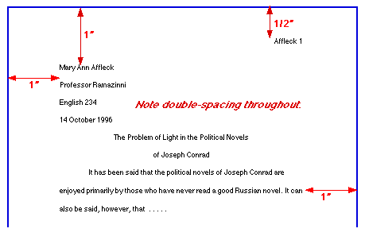

Required MLA Format for all headings for written assignments

Name
Teacher
Class/Period
Due Date
Title
Begin Here

COURSE CONTENT

Time Frame | Topic | Essential Questions | Grad at Grad
Quarter 1 | PERIOD 1: 1491-1607 | -How did the Columbian Exchange—the mutual transfer of material goods, commodities, animals, and diseases—affect interaction between Europeans and natives and among indigenous peoples in North America?  -Where did different groups settle in the Americas (before contact), and how and why did they move to and within the Americas (after contact)?  -How did Spain’s early entry into colonization in the Caribbean, Mexico, and South America shape European and American developments in this period?  -How did European attempts to dominate the Americas shape relations between Native Americans, Europeans, and Africans?  -How did pre-contact populations of North America relate to their environments? How did contact with Europeans and Africans change these relations in North America?  -How did cultural contact challenge the religious and other value systems of peoples from the Americas, Africa, and Europe? | -IC, CDJ, LC  -OG, IC, CDJ, RF,  -IC, CDJ, RF  -IC, CDJ, RF  -IC, CDJ, RF, LC  -IC, CDJ, RF, LC
Quarter 1 | Period 2: 1607-1754 | -What were the chief similarities and differences among the development of English, Spanish, Dutch, and French colonies in America?  -How did distinct economic systems, most notably a slavery system based on African labor, develop in British North America?  -Why did various colonists go to the New World?  -How did the increasing integration of the Atlantic world affect the movement of peoples between its different regions?  -How did the competition between European empires around the world affect relations among the various peoples in North America?  -How and why did the English North American colonies develop into distinct regions?  -How did the expansion of cultural contact that took place with permanent colonization alter conditions in North America and affect intellectual and religious life, the growth of trade, and the shape of political institutions? | -IC, CDJ, RF  -IC, CDJ, RF, LC  -OG, IC, CDJ, RF  -IC, CDJ, RF  -OG, IC, RF  -IC, CDJ, RF  -OG, IC, CDJ, RF
Quarter 1 | Period 3: 1607-1754, cont. | -How did different social group identities evolve during the revolutionary struggle?  -How did the newly independent United States attempt to formulate a national economy?  -How did the ideology behind the revolution affect power relationships between different ethnic, racial, and social groups?  -How did the revolution become an international conflict involving competing European and American powers?  -How did the geographical and environmental characteristics of regions opened up to white settlement after 1763 affect their subsequent development?  -Why did the patriot cause spread so quickly among colonists after 1763?  -How did republican ideals of the independence period affect the nation’s political culture? | -OG, IC, CDJ, RF  -OG, IC, LC  -OG, IC, CDJ, RF  -OG, IC, CDJ  -OG, IC, CDJ, RF, LC  -OG, IC, CDJ  -OG, IC, CDJ, RF, LC
Quarter 2 | Period 4: 1800-1848 | -How did debates over American democratic culture and the proximity of many different cultures living in close contact affect changing definitions of national identity?  -How did the growth of mass manufacturing in the rapidly urbanizing North affect definitions of and relationships between workers, and those for whom they worked? --How did the continuing dominance of agriculture and the slave system affect southern social, political, and economic life?  -How did the continued movement of individuals and groups into, out of, and within the United States shape the development of new communities and the evolution of old communities?  -How did the growth of ideals of mass democracy, including such concerns as expanding suffrage, public education, abolitionism, and care for the needy, affect political life and discourse?  -How did the United States use diplomatic and economic means to project its power in the western hemisphere?  -How did environmental and geographic factors affect the development of sectional economies and identities?  -How did the idea of democratization shape and reflect American arts, literature, ideals, and culture? | -IC, CDJ, LC  IC, CDJ, LC  -IC, CDJ, LC  -OG, IC, CDJ  -OG, IC, CDJ  -IC, CDJ, RF  -IC, CDJ  OG, IC, CDJ, RF, LC
Quarter 2 | PERIOD 5: 1844-1877 | -How did migration to the United States change popular ideas of American Identity and citizenship, as well as regional and racial identities?  -How did the conflicts that led to the Civil War change popular ideas about national, regional, and racial identities throughout this period?  -How did the maturing of northern manufacturing and the adherence of the South to an agricultural economy change the national economic system by 1877?  -How did the growth of mass migration to the United States and the railroad affect settlement patterns in cities and the West?  -Why did attempts at compromise before the war fail to prevent the conflict?  -To what extent, and in what ways, did the Civil War and Reconstruction transform American political and social relationships?  -How was the American conflict over slavery part of larger global events? How did the  world beyond North America perceive the civil war?  -How did the end of slavery and technological and military developments transform the environment and settlement patterns in the South and the West?  -How did the doctrine of Manifest Destiny affect debates over territorial expansionism and the Mexican War?  -How did the Civil War struggle shape Americans’ beliefs about equality, democracy, and national destiny? | OG, IC, CDJ  OG, IC, CDJ, LC  OG, IC, CDJ  OG, IC  IC, CDJ  -IC, CDJ  -OG, IC, CDJ, RF, LC  -OG, IC, CDJ  -OG, IC, CDJ, RF  -OG, IC, CDJ, RF, LC
Quarter 3 | Period 6: 1865-1898 | -How did the rapid influx of immigrants from other parts of the world than northern and western Europe affect debates about American national identity?  -How did technological and corporate innovations help to vastly increase industrial production? What was the impact of these innovations on the lives of working people?  -How and why did the sources of migration to the United States change dramatically during this period?  -How did the political culture of the Gilded Age reflect the emergence of new corporate power? How successful were the challenges to this power? Why did challenges to this power fail?  -How did the search for new global markets affect American foreign policy and territorial ambitions?  -In what ways, and to what extent, was the West “opened” for further settlement through connection to eastern political, financial, and transportation systems?  -How did artistic and intellectual movements both reflect and challenge the emerging corporate order? | -OG, IC, CD, OG  -IC, CDJ, RF, LCJ, RF  -OG, IC, C, OG  -IC, CDJ, RF, LCJ, RF  -OG, IC, CDJ  -OG, IC, CD, OG  -IC, CDJ, RF, LCJ, RF
Quarter 3 | Period 7: 1890-1945 | -How did continuing debates over immigration and assimilation reflect changing ideals of national and ethnic identity? How did class identities change in this period?  -How did movements for political and economic reform take shape in this period, and how effective were they in achieving their goals?  -Why did public attitudes towards immigration become negative during this time period? How and why did people migrate within the U.S. during this time period?  -How did reformist ideals change as they were taken up by reformers in different time periods? Why did opposition emerge to various reform programs?  -Why did U.S. leaders decide to become involved in global conflicts such as the Spanish-American War, World War I, and World War II? How did debates over intervention reflect public views of America’s role in the world?  -Why did reformers seek the government to wrest control of the environment and national resources from commercial interests?  -How did “modern” cultural values evolve in response to developments in technology? How did debates over the role of women in American public life reflect changing social realities? | -OG, IC, CDJ, RF, LC  -OG, IC, CDJ, RF, LC  -OG, IC, CDJ, RF, LC  -OG, IC, CDJ, RF, LC  -OG, IC, CDJ, RF,  -OG, IC, CDJ  -OG, IC, CDJ, RF, LC
Quarter 4 | Period 8: 1945-1980 | -How did the African-American Civil Rights movement affect the development of other movements based on asserting the rights of different groups in American society? How did American involvement in the Cold War affect debates over American national identity?  -How did the rise of American manufacturing and global economic dominance in the years after World War II affect standards of living among and opportunities for different social groups?  -How did the growth of migration to and within the United States influence demographic change and social attitudes in the nation?  -How did the changing fortunes of liberalism and conservatism in these years affect broader aspects of social and political power?  -Why did Americans endorse a new engagement in international affairs during the Cold War? How did this belief change over time in response to particular events?  -Why did public concern about the state of the natural environment grow during this period, and what major changes in public policy did this create?  -How did changes in popular culture reflect or cause changes in social attitudes? How did the reaction to these changes affect political and public debates? | -OG, IC, CDJ, RF, LC  -OG, IC, CDJ, RF  -OG, IC, CDJ, RF, LC  -OG, IC, CDJ, RF, LC  -OG, IC, CDJ, RF, LC  -OG, IC, CDJ  -OG, IC, CDJ, RF, LC
Quarter 4 | PERIOD 9: 1980-present | -How did demographic and economic changes in American society affect popular debates over American national identity?  -How did the shift to a global economy affect American economic life?  -How did increased migration raise questions about American identity and affect the nation demographically, culturally, and politically?  -How did the end of the Cold War affect US foreign policy from 1990 onwards? How did the attacks of September 2001 impact America’s role in the world?  -How did debates over climate change and energy policy affect broader social and political movements?  -How did technological and scientific innovations in areas such as electronics, biology, medicine, and communications affect society, popular culture, and public discourse? | -OG, IC, CDJ, RF, LC  -OG, IC, CDJ, RF  -OG, IC, CDJ, RF, LC  -OG, IC, CDJ, RF, LC  -OG, IC, CDJ, RF, LC  -OG, IC, CDJ, RF, LC

OG – Open to Growth, IC – Intellectually Competent, CDJ – Committed to Doing Justice,
RF – Religious and Faithful, LC – Loving and Compassionate

